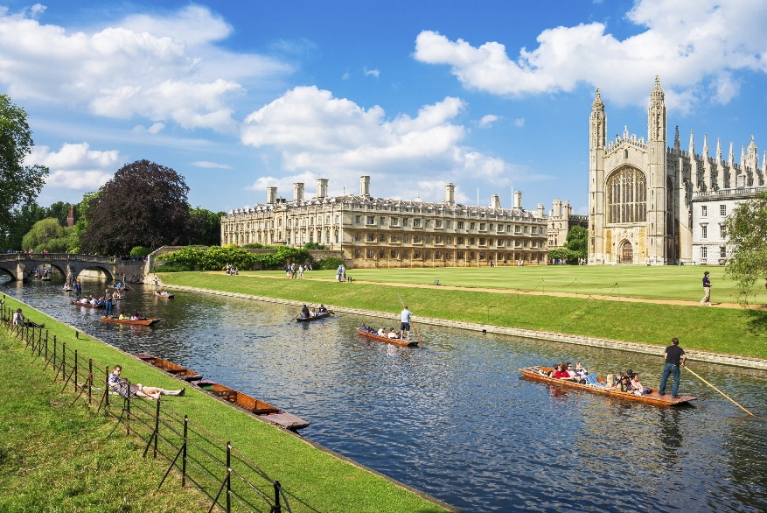
Cambridgeshire County Council Pension Fund
Year ended 31 March 2018
The Cambridgeshire County Council Pension Fund is a Local Government Pension Fund, administered by Cambridgeshire County Council. Other organisations, such as District and Town Councils, academies, charities and outsourced contractors are also employers in the Fund.
Each year, the Fund publishes its financial accounts within the County Council’s Statement of Accounts, which you can find on the County Council’s website:
https://www.cambridgeshire.gov.uk/council/finance-and-budget/statement-of-accounts/
The Fund also publishes its Annual Report and Statement of Accounts, which contains the same financial information as that within the County Council Statement of Accounts, but contains additional information about how the Fund is run and how it has performed over the last year.
All page numbers in this handout refer to the Pension Fund’s Annual Report and Statement of Accounts, which can be found at the Fund’s Website:
http://pensions.cambridgeshire.gov.uk/governance/key-documents/cambridgeshire/
Words in bold are explained in the glossary to the Annual Report and Statement of Accounts.

This handout summarises key areas of the Fund; Contributions and Benefits, costs of running the Fund (Management Expenses), Employers and Members of the Fund, Investments, and the Governance of the Fund.
Contributions and Benefits
Employers contribute to the Fund in line with rates calculated by the Fund’s Actuary. Employee rates are set by Government.
Contributions and monies transferred into the Fund are used to pay Pensions (Benefits) and Payments to Leavers. The remaining contributions are then used to pay the running costs of the Fund. The remaining surplus is invested to pay for accrued Pensions. The table below sets out the Contributions and Benefits for the last two financial years:
All figures in £000 | 2016-17 | 2017-18
Contributions | 125,448 | 128,410
Transfers in | 3,292 | 4,932
Benefits | (98,387) | (99,345)
Payments to leavers | (10,421) | (10,126)
Surplus | 19,932 | 23,871
You can find more information on Contributions and Benefits in Notes 7 and 9 to the Statement of Accounts.
Management Expenses
The cost of running the Fund is broken down into three areas, as shown in Note 11 to the Statement of Accounts in the Fund’s Annual Report and Statement of Accounts.
Administrative Costs are the costs of providing support to members and employers and include staff, premises, IT and other expenses incurred in the administration of the scheme. Cambridgeshire County Council has appointed LGSS to provide Pension Administration services. This is a joint arrangement with Northamptonshire County Council. The section 114 notice issued at Northamptonshire County Council has no impact on LGSS delivering administration and management services to the Cambridgeshire Pension Fund.

There are more details about Administrative Costs in the Administrative Management Performance section of the Fund’s Annual Report.
Oversight and Governance Costs are costs incurred in ensuring the scheme is well run. These include training costs for Councillors, Actuary and Audit services and Legal support. You can find further details in the Governance policy and compliance statement in the Annual Report.
Investment Management Expenses include fees paid to Investment Managers, specialist advisors, and the costs of buying, selling and holding investments.
You can find more details in the Investment policy and performance report in the Fund’s Annual Report.
Employer and Member Numbers
There are 342 Employer bodies within the Pension Fund, 206 of whom are active. A full list of can be found in the Annual Report on pages 7-9. Details of contributions made by Employers and their Employees can be found on pages 24-30 of the Annual Report.
The Fund has 27,497 active members (members who are contributing) and 18,054 members who are drawing their pension. There are 35,265 members who no longer contribute to the Fund but are yet to retire (deferred members). More information about the Fund’s membership can be found on page 23 of the Annual Report.
The Fund has seen a steady increase in the number of Employers and Members within the scheme over the last few years.

Investments
The investment strategy focusses on growing the investment assets of the Fund to meet future pension payments, taking appropriate risk.
The Fund invests in a wide range of assets to spread investment risk across markets, countries and investment type. Specialist Investment Managers manage the Fund’s investments and a list of the Fund’s Investment Managers and the assets they hold can be found in the Investment policy and performance report, starting on page 31 of the Fund’s Annual Report and Statement of Accounts.
All investment assets are held securely by the Fund’s Custodian, Northern Trust.
Investment Risks
There are many risks inherent in investments. The Fund addresses these in the following ways:
Market risk – investments will reduce in value due to fluctuations in prices, interest rates, exchange rates and credit spreads. | The Fund invests in different markets across the world and in different types of investment to reduce the risk of the portfolio reducing in value.
Price risk – investments may be incorrectly valued due to price fluctuations or estimates used in pricing. | Investments are valued at published prices, where available. Investments that are not sold on a market are valued by specialist investment managers. Notes 16, 17 and 18 in the Statement of Accounts gives information about how investments are valued and gives an indication of the value of investments subject to an element of estimation.
Note 18 in the Statement of Accounts gives more information on risks affecting the Fund’s investments and shows how sensitive the investment values are to changes to these risks.

Investment Performance
The Fund holds investments over the long-term in order to maximise return. Due to changeable market conditions, investments will do well in some years and less well in others. The Fund’s Annual Report and Statement of Accounts gives greater details about the Investment Managers the Fund uses, how much money they hold and how the Fund has performed. See pages 31 to 45 for more information.
The Fund’s investment performance, compared to other LGPS funds, is shown below:

The table below gives an overview of the Fund’s assets at 31 March 2018:
All figures in £000 |  | 2016-17 | 2017-18
UK | Bonds | 74,590 | 74,578
 | Equities | 1,021,667 | 615,088
 | Fixed Income | 67,173 | 68,404
 | Property | 192,549 | 206,671
Overseas | Equities | 935,482 | 1,394,956
 | Fixed Income | 223,406 | 228,902
Mixed | Private Equity | 246,179 | 274,393
 | Cash | 50,663 | 49,505
Debtors/(Creditors) |  | 1,577 | 3,535
Total |  | 2,813,286 | 2,916,032

Governance
The activities of the Fund are governed by the Pensions Committee, with investment monitoring undertaken by the Investment Sub-Committee. Members of the Committee include representatives of employing bodies as well as scheme members.
The Local Pension Board has responsibility for ensuring there is effective and efficient governance and administration of the Fund. Membership of the Board is split evenly across employer and scheme member representatives
A full list of County Councillor, Employer and Member representatives on these committees can be found on the Fund’s website or within the Governance Policy and Compliance Statement in the Fund’s Annual Report and Statement of Accounts.

