Cash Management Strategy Published 29 June 2023

- Regulations
    - Under The Local Government Pension Scheme (Management and Investment of Funds) Regulations 2016 the Fund is required to have its own separate bank account (paragraph 6.1). A number of other instructions are set out in the regulations regarding managing the Funds cash, these are listed below.
    - Regulation 5 – Restriction on power to borrow. This regulation states that an authority may only borrow by way of temporary loan or overdraft for the purpose of paying benefits due under the scheme or to meet investment commitments. The authority may only borrow if it reasonably believes that the sum borrowed and interest charged can be repaid by the pension fund within 90 days of borrowing.
    - Regulation 7.8 – Investment Strategy Statement. The authority must invest, in accordance with its investment strategy, any fund money that is not needed immediately to make payments from the fund.

- Other Regulatory Influences
- The Fund will also have regard to:
- Treasury Management in the Public Services: Code of Practice and Cross-Sectoral Guidance Notes (Treasury Management Code) (2011),
- MHCLG Investment Guidance,
- The UK Money Markets Code,
- EU Money Market Funds (MMF) Regulation.

- Objectives
- The main objectives of a Cash Management Strategy are to ensure that:
- The Fund is compliant with The Local Government Pension Scheme (Management and Investment of Funds) Regulations 2016,
- Cash is available as and when required,
- Surplus cash is invested,
- Risks inherent within the Key Principles are managed.

- Key Principles
- There are three key principles relating to cash management:
- Security – Safeguarding Pension Fund assets,
- Liquidity – Ensuring the Pension Fund has cash available as and when required,
- Yield – To achieve a market return.

- Overdraft
- An overdraft is a form of borrowing and the 2016 Regulations specify only two reasons that the Fund can legally overdraw, as set out in paragraph 1.1.1. above.
- The Fund bank accounts operate with a zero aggregate overdraft facility, with strong financial control processes over cash activities.
- Cash Arrangements
- The Fund currently holds cash at Barclays and at the Fund’s Custodian Northern Trust, both of which have access to interest bearing accounts. There is no cash held with the Administering Authority.
- Barclays Bank Plc
Operational cash is held at Barclays Bank, managed directly by Officers. A minimal balance is maintained, varying upon the information available from the three key interfaces:
- Accounts Receivable - this account receives all contributions, transfers and invoiced income.
- Payroll Account – Pension benefits are paid from this account monthly.
- Payables Account – All invoice payments, grants and lump sums are payments are made from this account.
At close of business each day any surplus/shortfall on the above accounts are swept into an overarching interest bearing Liquidity Account to ensure a residual balance of £10,000 on each.
- Northern Trust (Custodian)
The Fund will transfer surplus money from Barclays Bank accounts to the Fund’s account at the Custodian for investment in line with the Fund’s Investment Strategy. This account also acts as a gateway to receive and pay monies to Investment Managers, for example, cash from Investment distributions. The Fund has a contractual agreement with the Custodian to sweep excess cash into Money Market Funds.
- Investment Managers
Investment managers hold cash at Northern Trust as part of their mandates. Whilst this cash is under the managers’ control, it can be recalled by the Fund.
- Key Cash Flow Movements/Timings
- Barclays Bank
The key activities that occur within the Barclay’s accounts, noted at 6.2. above are monitored by Officers through regular profiling of cash movements, which identifies surplus balances or forecast shortfalls, prompting a transfer of cash to, or from, the Custodian.
There are three streams of activity; receipt of income through Accounts Receivable, payment of pension benefits through payroll and ad hoc payments through Accounts Payable. Contribution income is required to be received by the 19th of the month. This is important as it represents the receipt of income prior to the payment of the pensioners’ payroll on the 25th of the month. The payments through Accounts Payable occur on an irregular pattern dependent upon demand, with the main activity being the payment of new pension liabilities such as retirement grants, in addition to death grants, transfers out and refunds.

- Custodian
Officers manage the Fund’s cash requirements and will first recall cash from the Custodian cash account, then from Investment Managers, giving regard to the asset allocation, liquidity and exit costs of investment assets, as required. Similarly, investing of Fund surpluses will also be in line with the Fund’s Investment Strategy.
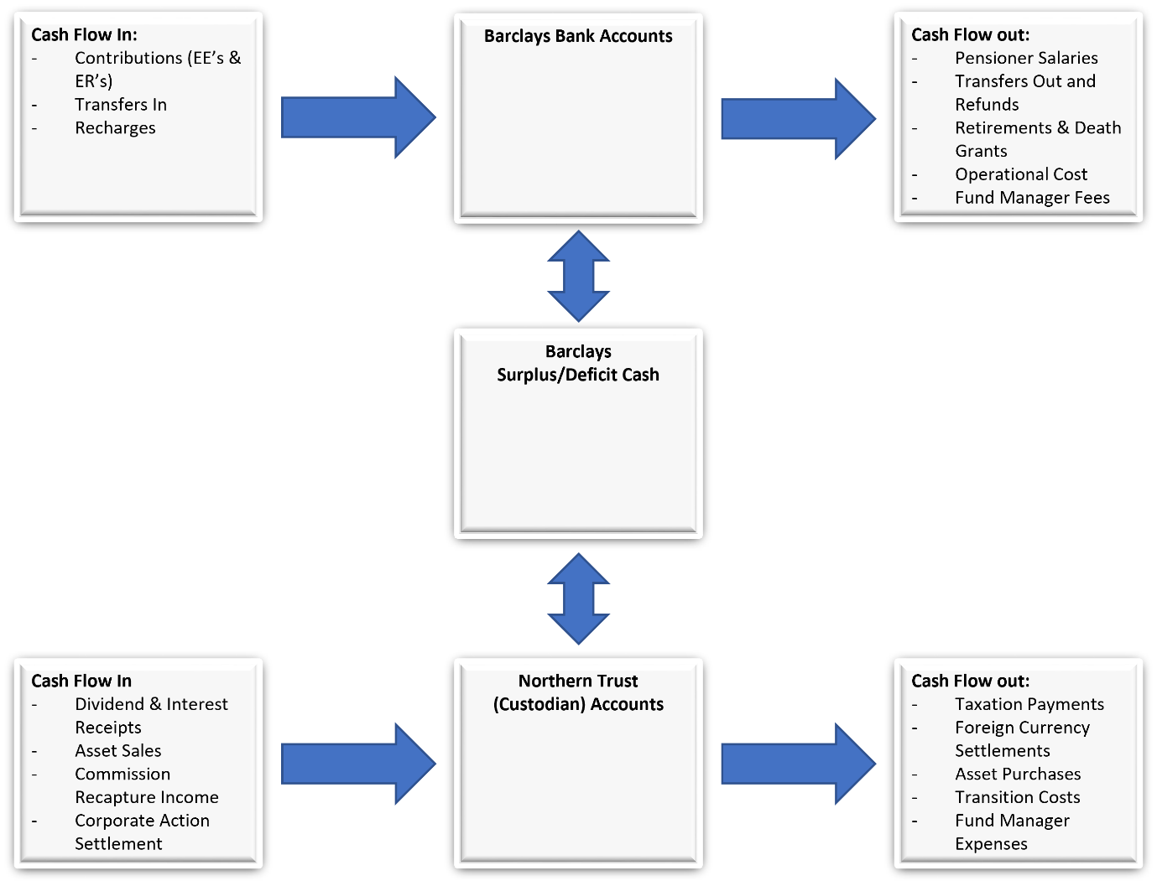

- Operational Issues
Risk | Implication | Mitigation
Exit payments, where cash is due to Employers within the Fund who have a contribution surplus, and Employers transferring their assets and liabilities out of the Fund, generate risks to cash flows and the balance of cash within the Fund. | - Becoming overdrawn  - Lack of liquidity to fund payments | - Clear inter-team communication  - Segregation of duties  - Sale of assets
Timing of payments result in payments exceeding the working balance held at Barclays Bank, requiring a recall of cash from the Custodian. | - Becoming overdrawn  - Lack of liquidity to fund payments | -Stringent cash management and forecasting  -Ability to delay non-essential payments to ease cashflow
A dependency upon Treasury to action instructions from the Pension Fund in a timely manner. | - Lack of liquidity to fund payments | -Stringent cash management and forecasting  - Segregation of duties
An investment draw down where insufficient cash is held by the Custodian on behalf of the Fund. | - Becoming overdrawn  - Lack of liquidity to fund payments | - Stringent cash management and forecasting
County Council officers, with access to Pensions systems, can action fraudulent or erroneous cash movements. | - Becoming overdrawn  - Payments made to/from wrong bank account  - Fraudulent activities | - Segregation of duties  - Approval from Pension Senior Management required for cash movements
Surplus cash is not invested in line with the Investment Strategy Statement on a timely basis. | - Loss of economic benefit to the Fund | - Stringent cash management  - Clear inter-team Communication

- Effective date and reviews

    - The policy was first approved by the Pension Fund Committee on 23 March 2019 and was effective from 24 March 2019. The policy has since been subject to the following reviews:

Date of review | Policy effective date:
28 June 2023 | 29 June 2023

- Glossary
Custodian – An external body responsible for ensuring the investing Fund’s assets are registered in the name of the Fund, managing the settlement of trades, collecting income arising and reporting transactions and values to the Fund on a regular basis.
Deficit – An outcome where expenses exceed income.
Investment Manager – An external organisation that makes investments in assets on behalf of clients.
Money Market – A mutual fund that invests in cash and cash equivalent securities.
Surplus – An outcome where income exceeds expenditure.

